**15-17年各专业考试质量分析表**

|  |  |
| --- | --- |
| 序号 | 佐证材料目录 |
| 01 | 15-17年文化课考试质量分析表（部分） |
| 02 | 16-17年近两年文化厅统考成绩（部分） |
| 03 | 表演系教学质量分析表（部分） |
| 04 | 设计系教学质量分析表（部分） |
| 05 |  |
| 06 |  |
| 07 |  |
| 08 |  |
| 09 |  |

|  |  |  |  |  |  |  |  |  |  |  |  |  |  |  |  |  |  |  |  |  |  |  |
| --- | --- | --- | --- | --- | --- | --- | --- | --- | --- | --- | --- | --- | --- | --- | --- | --- | --- | --- | --- | --- | --- | --- |
| 2014级英语6统一考试情况汇总表 | | | | | | | | | | | | | | | | | | | | | | |
| 系 部 | 公共基础部 | | | | | | | | | | | | | | | | | | | | | |
| 班 级 | 14播音1班 | | 14播音2班 | | 14表演班（声乐） | | 14表演班（器乐） | | 14环艺班 | | 14服装班 | | 14平面班 | | 14工美班 | | 14动画1班 | | 14动画2班 | | 14中国舞 | |
| 任课教师 | 王芳 | | 杨洁 | | 王芳 | | 王芳 | | 杨洁 | | 谈志芬 | | 谈志芬 | | 谈志芬 | | 王芳 | | 王芳 | | 英语外聘003 | |
| 人 数 | 27 | | 33 | | 15 | | 10 | | 29 | | 33 | | 34 | | 28 | | 32 | | 35 | | 11 | |
| 最高分 | 86 | | 80 | | 74 | | 90 | | 81 | | 85 | | 94 | | 66 | | 85 | | 80 | |  | |
| 最低分 | 40 | | 18 | | 22 | | 15 | | 16 | | 35 | | 47 | | 28 | | 23 | | 14 | |  | |
| 分数段 | 人数 | 百分比 | 人数 | 百分比 | 人数 | 百分比 | 人数 | 百分比 | 人数 | 百分比 | 人数 | 百分比 | 人数 | 百分比 | 人数 | 百分比 | 人数 | 百分比 | 人数 | 百分比 | 人数 | 百分比 |
| 0—9 | 0 | 0% | 0 | 0% | 0 | 0% | 0 | 0% | 0 | 0% | 0 | 0% | 0 | 0% | 0 | 0% | 0 | 0% | 0 | 0% |  |  |
| 10—19 | 0 | 0% | 1 | 3.7% | 0 | 0% | 1 | 10% | 2 | 7.41% | 0 | 0% | 0 | 0% | 0 | 0% | 0 | 0% | 2 | 5.88% |  |  |
| 20—29 | 0 | 0% | 1 | 3.7% | 3 | 21.43% | 2 | 20% | 0 | 0% | 0 | 0% | 0 | 0% | 1 | 3.7% | 3 | 9.68% | 9 | 26.47% |  |  |
| 30—39 | 0 | 0% | 3 | 11.11% | 3 | 21.43% | 0 | 0% | 5 | 18.52% | 1 | 3.23% | 0 | 0% | 4 | 14.81% | 0 | 0% | 2 | 5.88% |  |  |
| 40-49 | 2 | 8% | 5 | 18.52% | 0 | 0% | 3 | 30% | 6 | 22.22% | 0 | 0% | 2 | 6.06% | 9 | 33.33% | 7 | 22.58% | 4 | 11.76% |  |  |
| 50—59 | 3 | 12% | 7 | 25.93% | 4 | 28.57% | 0 | 0% | 9 | 33.33% | 3 | 9.68% | 4 | 12.12% | 5 | 18.52% | 6 | 19.35% | 6 | 17.65% |  |  |
| 60—69 | 6 | 24% | 5 | 18.52% | 2 | 14.29% | 2 | 20% | 3 | 11.11% | 10 | 32.26% | 9 | 27.27% | 8 | 29.63% | 7 | 22.58% | 10 | 29.41% |  |  |
| 70—79 | 10 | 40% | 4 | 14.81% | 2 | 14.29% | 1 | 10% | 1 | 3.7% | 14 | 45.16% | 10 | 30.3% | 0 | 0% | 5 | 16.13% | 0 | 0% |  |  |
| 80—89 | 4 | 16% | 1 | 3.7% | 0 | 0% | 0 | 0% | 1 | 3.7% | 3 | 9.68% | 6 | 18.18% | 0 | 0% | 3 | 9.68% | 1 | 2.94% |  |  |
| 90—100 | 0 | 0% | 0 | 0% | 0 | 0% | 1 | 10% | 0 | 0% | 0 | 0% | 2 | 6.06% | 0 | 0% | 0 | 0% | 0 | 0% |  |  |
| 平均成绩 | 68.28 | | 53.56 | | 47.93 | | 47 | | 49.63 | | 69.42 | | 70.27 | | 49.78 | | 57.19 | | 45.24 | |  | |
| 年级排名 | 3 | | 5 | | 8 | | 9 | | 7 | | 2 | | 1 | | 6 | | 4 | | 10 | |  | |
| 及格率 | 80% | | 37.04% | | 28.57% | | 40% | | 18.52% | | 87.1% | | 81.82% | | 29.63% | | 48.39% | | 32.35% | |  | |
| 2015级语文4统一考试情况汇总表 | | | | | | | | | | | | | | | | | | | | | | |
| 系 部 | 公共基础部 | | | | | | | | | | | | | | | | | | | | | |
| 班 级 | 15播音1班 | | 15播音2班 | | 15表演班（声乐） | | 15表演班（器乐） | | 15环艺班 | | 15服装班 | | 15平面班 | | 15工美班 | | 15动画1班 | | 15动画2班 | | 15中国舞 | |
| 任课教师 | 黄学义 | | 刘丽 | | 孔庆霞 | | 孔庆霞 | | 黄学义 | | 孔庆霞 | | 黄学义 | | 孔庆霞 | | 孔庆霞 | | 孔庆霞 | | 语文外聘002 | |
| 人 数 | 40 | | 40 | | 18 | | 14 | | 35 | | 35 | | 34 | | 28 | | 36 | | 34 | | 18 | |
| 最高分 | 83 | | 85 | | 76 | | 78 | | 87 | | 85 | | 80 | | 85 | | 83 | | 81 | |  | |
| 最低分 | 42 | | 45 | | 51 | | 40 | | 48 | | 48 | | 44 | | 38 | | 33 | | 29 | |  | |
| 分数段 | 人数 | 百分比 | 人数 | 百分比 | 人数 | 百分比 | 人数 | 百分比 | 人数 | 百分比 | 人数 | 百分比 | 人数 | 百分比 | 人数 | 百分比 | 人数 | 百分比 | 人数 | 百分比 | 人数 | 百分比 |
| 0—9 | 0 | 0% | 0 | 0% | 0 | 0% | 0 | 0% | 0 | 0% | 0 | 0% | 0 | 0% | 0 | 0% | 0 | 0% | 0 | 0% |  |  |
| 10—19 | 0 | 0% | 0 | 0% | 0 | 0% | 0 | 0% | 0 | 0% | 0 | 0% | 0 | 0% | 0 | 0% | 0 | 0% | 0 | 0% |  |  |
| 20—29 | 0 | 0% | 0 | 0% | 0 | 0% | 0 | 0% | 0 | 0% | 0 | 0% | 0 | 0% | 0 | 0% | 0 | 0% | 1 | 2.94% |  |  |
| 30—39 | 0 | 0% | 0 | 0% | 0 | 0% | 0 | 0% | 0 | 0% | 0 | 0% | 0 | 0% | 1 | 3.57% | 4 | 11.43% | 0 | 0% |  |  |
| 40-49 | 3 | 7.89% | 1 | 2.5% | 0 | 0% | 2 | 14.29% | 1 | 3.03% | 1 | 3.03% | 3 | 9.09% | 4 | 14.29% | 8 | 22.86% | 3 | 8.82% |  |  |
| 50—59 | 8 | 21.05% | 11 | 27.5% | 8 | 57.14% | 7 | 50% | 6 | 18.18% | 3 | 9.09% | 3 | 9.09% | 8 | 28.57% | 13 | 37.14% | 7 | 20.59% |  |  |
| 60—69 | 10 | 26.32% | 11 | 27.5% | 5 | 35.71% | 3 | 21.43% | 7 | 21.21% | 6 | 18.18% | 13 | 39.39% | 5 | 17.86% | 6 | 17.14% | 11 | 32.35% |  |  |
| 70—79 | 12 | 31.58% | 10 | 25% | 1 | 7.14% | 2 | 14.29% | 13 | 39.39% | 18 | 54.55% | 13 | 39.39% | 7 | 25% | 3 | 8.57% | 10 | 29.41% |  |  |
| 80—89 | 5 | 13.16% | 7 | 17.5% | 0 | 0% | 0 | 0% | 6 | 18.18% | 5 | 15.15% | 1 | 3.03% | 3 | 10.71% | 1 | 2.86% | 2 | 5.88% |  |  |
| 90—100 | 0 | 0% | 0 | 0% | 0 | 0% | 0 | 0% | 0 | 0% | 0 | 0% | 0 | 0% | 0 | 0% | 0 | 0% | 0 | 0% |  |  |
| 平均成绩 | 66.87 | | 67.45 | | 59.43 | | 58.29 | | 70.15 | | 70.85 | | 66.85 | | 63.14 | | 54.31 | | 63.53 | |  | |
| 年级排名 | 4 | | 3 | | 8 | | 9 | | 2 | | 1 | | 5 | | 7 | | 10 | | 6 | |  | |
| 及格率 | 71.05% | | 70% | | 42.86% | | 35.71% | | 78.79% | | 87.88% | | 81.82% | | 53.57% | | 28.57% | | 67.65% | |  | |

|  |  |  |  |  |  |  |  |
| --- | --- | --- | --- | --- | --- | --- | --- |
| **2015-2016学年第二学期省艺术类学校**  **教考分离（英语）科目成绩统计表** | | | | | | | |
| **学校** | **专业** | **2015级** | | **2014级** | | **2013级** | |
| **平均分** | **及格率** | **平均分** | **及格率** | **平均分** | **及格率** |
| 常州艺校 | 设计 | 64.97 | 65.67 | 73.43 | 79.03 | 71.02 | 76.67 |
| 动画 | 51.51 | 30.43 | 60.81 | 53.85 | 64.93 | 66.15 |
| 表演 | 59.4 | 45.16 | 66.05 | 60.87 | 76.92 | 85.00 |
| 播音 | 56.15 | 41.77 | 81.50 | 93.10 | 80.95 | 94.34 |
| 淮安艺校 | 美发 | 21.99 | 0.00 | 27.72 | 2.70 |  |  |
| 美术设计 | 21.63 | 0.00 | 28.29 | 3.85 |  |  |
| 导游 | 20.88 | 0.00 |  |  |  |  |
| 音乐 | 25.55 | 1.61 | 27.10 | 0.00 |  |  |
| 省戏校 | 4301 | 63.41 | 65.08 | 57.15 | 62.50 | 53.22 | 50.85 |
| 4302 | 48.98 | 52.50 | 54.47 | 38.46 | 63.14 | 73.91 |
| 4303 | 42.71 | 13.79 |  |  |  |  |
| 4305 | 38.52 | 13.79 | 34.72 | 13.04 |  |  |
| 徐州艺校 |  | 60.47 | 64.71 | 40.76 | 0.00 |  |  |
| 苏州艺校 | 昆曲 | 49.39 | 27.78 | 62.33 | 66.67 | 43.58 | 15.00 |
| 美术 | 13.75 | 0.00 | 46.89 | 30.00 |  |  |
| 苏州评弹 |  | 57.76 | 51.67 | 60.12 | 55.10 | 78.48 | 90.91 |
| 扬州艺校 | 02 | 47.22 | 43.59 | 41.42 | 9.09 |  |  |
| 04 | 58.64 | 42.86 | 31 | 0.00 |  |  |
| 06 |  |  | 32.84 | 5.26 |  |  |
| 07 |  |  | 30.64 | 9.09 |  |  |
| 无锡艺校 | 中国舞 | 82.24 | 88.24 |  |  |  |  |
| 国标舞 | 79.39 | 83.33 |  |  |  |  |
| 音乐 | 35.67 | 17.39 |  |  |  |  |
| 表演 | 60.67 | 66.67 |  |  |  |  |
| 播音 | 67.22 | 77.78 |  |  |  |  |
| 锡剧 | 85.82 | 100 |  |  |  |  |

|  |  |  |  |  |  |  |  |  |
| --- | --- | --- | --- | --- | --- | --- | --- | --- |
| **2016-2017学年省艺术类学校五年制高职**  **教考分离（德育）科目成绩统计表** | | | | | | | | |
| **学校** | **专业** | **学制** | **2016级** | | | | | |
| **应考人数** | **实考人数** | **最高分** | **最低分** | **平均分** | **及格率** |
| 常州艺术高等职业学校 | 考场1（1001-1032） | 五年制 | 27 | 27 | 84 | 52 | 70.89 | 92.59% |
| 考场2（1033-1063） | 五年制 | 30 | 30 | 77 | 57 | 67.43 | 93.33% |
| 考场3(1064-2016) | 五年制 | 30 | 29 | 81 | 56 | 68.66 | 89.66% |
| 考场4(2017-3010) | 五年制 | 28 | 28 | 92 | 53 | 71.11 | 85.71% |
| 考场5(3011-3040) | 五年制 | 30 | 30 | 88 | 65 | 74.7 | 100% |
| 考场6(3041-3070) | 五年制 | 30 | 30 | 99 | 68 | 80.73 | 100% |
| 考场7(3071-3103) | 五年制 | 30 | 30 | 90 | 63 | 75.48 | 100% |
| 考场8(3104-3133) | 五年制 | 30 | 30 | 91 | 61 | 76.1 | 100% |
| 考场9(3134-3164) | 五年制 | 30 | 30 | 86 | 55 | 71.52 | 89.66% |
| 考场10(3165-4040) | 五年制 | 45 | 45 | 89 | 58 | 70.44 | 97.78% |
| 苏州评弹学校 | 16戏曲表演（1班） | 五年制 | 26 | 26 | 95 | 59 | 81.46 | 96.15% |
| 16戏曲表演（2班） | 五年制 | 30 | 30 | 99 | 70 | 85.27 | 100%% |
| 江苏省戏剧学校 | 16锡剧（琢玉楼303） | 五年制 | 19 | 19 | 83 | 53 | 67.68 | 68.42% |
| 16锡剧（图书馆） | 五年制 | 16 | 16 | 86 | 55 | 65.5 | 68.75% |
| 16器乐 | 五年制 | 28 | 28 | 81 | 57 | 70.11 | 96.43% |
| 16声乐 | 五年制 | 25 | 25 | 80 | 48 | 64.36 | 80% |
| 16艺设1 | 五年制 | 24 | 24 | 93 | 54 | 70.08 | 83.33% |
| 16艺设2 | 五年制 | 23 | 23 | 94 | 63 | 75.57 | 100% |
| 16影话 | 五年制 | 22 | 22 | 84 | 57 | 69.36 | 90.91% |
| 苏州市艺术学校 | 16昆曲 | 五年制 | 19 | 19 | 75 | 53 | 66.26 | 89.47% |

|  |  |  |  |  |  |  |  |  |  |  |  |  |  |  |
| --- | --- | --- | --- | --- | --- | --- | --- | --- | --- | --- | --- | --- | --- | --- |
| **2016-2017学年第二学期江苏省艺术类学校（语文）统考成绩分析表** | | | | | | | | | | | | | | |
| **参考学校** | **实际参考人数** | **学制** | **年级** | **平均分** | **80以上** | **79-70** | **69-60** | **59-50** | **49-40** | **39-30** | **29-20** | **20以下** | **及格人数** | **及格率** |
| 常熟高新园中专 | 130 | 三年制 | 一年级 | 57.42 | 0 | 9 | 47 | 53 | 17 | 2 | 1 | 1 | 56 | 43.08% |
| 苏州艺校 | 12 | 三年制 | 一年级 | 53.5 | 0 | 1 | 2 | 5 | 4 | 0 | 0 | 0 | 3 | 25.00% |
| 淮安艺校 | 268 | 三年制 | 一年级 | 50.05 | 1 | 7 | 49 | 92 | 87 | 18 | 6 | 8 | 57 | 21.27% |
| 江苏模特艺术学校 | 72 | 三年制 | 一年级 | 61.79 | 1 | 20 | 32 | 8 | 4 | 4 | 1 | 2 | 53 | 73.61% |
| 扬州艺校 | 111 | 三年制 | 一年级 | 51.77 | 0 | 7 | 32 | 28 | 29 | 7 | 3 | 5 | 39 | 35.14% |
| **参考学校** | **实际参考人数** | **学制** | **年级** | **平均分** | **80以上** | **79-70** | **69-60** | **59-50** | **49-40** | **39-30** | **29-20** | **20以下** | **及格人数** | **及格率** |
| 常州艺校 | 305 | 五年制 | 一年级 | 69.63 | 54 | 107 | 105 | 31 | 8 | 0 | 0 | 0 | 266 | 87.21% |
| 苏州艺校 | 19 | 五年制 | 一年级 | 62.89 | 0 | 2 | 10 | 7 | 0 | 0 | 0 | 0 | 12 | 63.16% |
| 江苏省戏剧学校 | 158 | 五年制 | 一年级 | 65.05 | 19 | 35 | 57 | 39 | 5 | 2 | 0 | 0 | 111 | 70.25% |
| 苏州评弹学校 | 57 | 五年制 | 一年级 | 66.21 | 2 | 18 | 23 | 12 | 2 | 0 | 0 | 0 | 43 | 75.44% |
| 常州艺校 | 255 | 五年制 | 三年级 | 63.99 | 14 | 54 | 110 | 59 | 18 | 0 | 0 | 0 | 178 | 69.80% |
| 苏州艺校 | 15 | 五年制 | 三年级 | 57.63 | 0 | 0 | 7 | 6 | 2 | 0 | 0 | 0 | 7 | 46.67% |
| 江苏省戏剧学校 | 109 | 五年制 | 三年级 | 54.2 | 1 | 13 | 35 | 32 | 16 | 3 | 0 | 9 | 49 | 44.95% |
| 苏州评弹学校 | 46 | 五年制 | 三年级 | 67.15 | 4 | 16 | 20 | 2 | 4 | 0 | 0 | 0 | 40 | 86.96% |

表演系期中教学质量分析表

（2015-2016学年度第二学期）

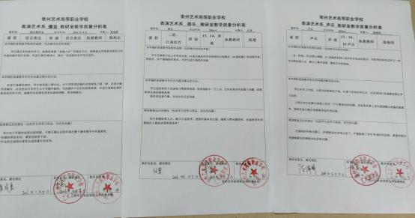

表演系期末教学质量分析表

（2015-2016学年度第二学期）

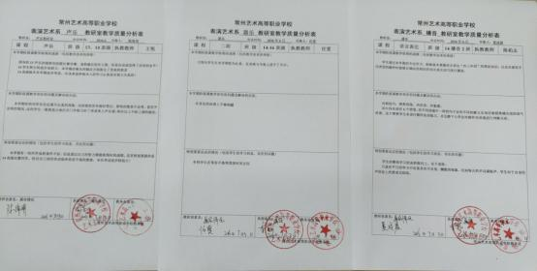

表演系期中教学质量分析表

（2016-2017学年度第一学期）

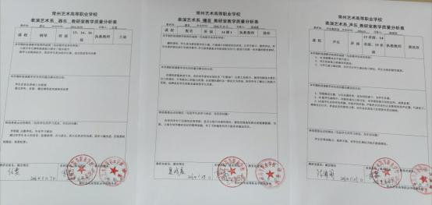

表演系期末教学质量分析表

（2016-2017学年度第一学期）

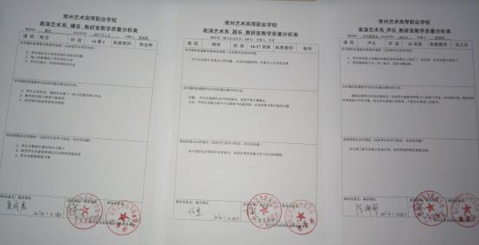

表演系期中教学质量分析表

（2016-2017学年度第二学期）

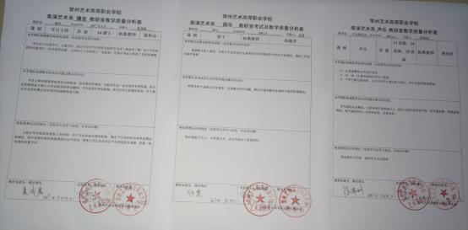

表演系期末教学质量分析表

（2016-2017学年度第二学期）

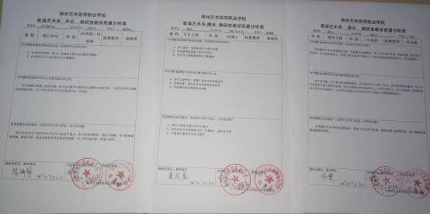

表演系期中教学质量分析表

（2017-2018学年度第一学期）

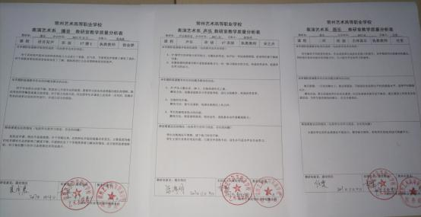

表演系期末教学质量分析表

（2017-2018学年度第一学期）

